Details of Aim 1: Build capacity for three community partnerships to advance IHE in SF

1a. Integrative Approaches to Healthy Aging

Project Team: Evelyn Y. Ho, PhD (project co-lead, USF), Sunny Pak (project co-lead, On Lok), Maria T. Chao, DrPH, MPA (collaborator, OCIH), USF student intern, IHEAR predoctoral fellow, bilingual project coordinator

Description of Community Partner

On Lok is a nonprofit organization with multiple centers in San Francisco dedicated to empowering people to age with dignity and independence. Their Program of All-Inclusive Care for the Elderly (PACE) focuses on holistic care and services for elderly people who are 72% Asian and 55% Chinese speaking. The exercise program at PACE at the Powell Street site currently relies solely on tai chi YouTube videos that are not well adapted for their clientele who often use walkers and canes. We plan to build on these offerings to meet the needs of Chinese-speaking elders. In our prior work we co-created the Integrative Nutritional Counseling (INC) as a culturally-centered, evidence-informed nutrition program with multilingual (Cantonese, Mandarin, English) guides for type 2 diabetes self-management and for heart health promotion (Ho et al., 2021; Ho et al., 2020). We will expand the successful INC program by adding movement exercises from tai chi and qi gong that are suitable for seniors with various physical abilities. INC was created and tested by a team from OCIH, UCSF Division of General Internal Medicine, and the University of San Francisco in partnership with Dr. Sunny Pak (Powell Street, Associate Medical Director) when he was previously at Chinatown Public Health Center. Dr. Pak is a physician and acupuncturist, has been an integral collaborator on the development of this proposal, and will be the primary partner within On Lok.

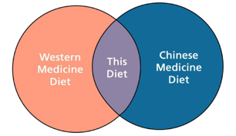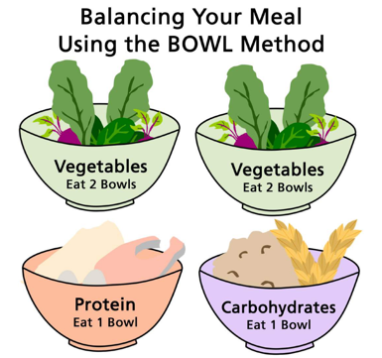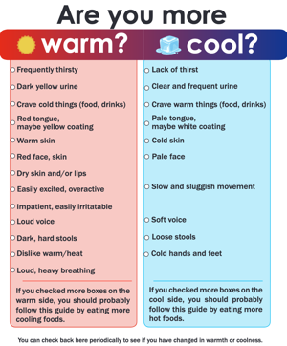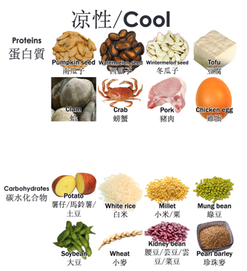
Images from existing INC patient education materials

Project Goals to Build Capacity for IHE

- Co-create an adapted tai chi/ qi gong-based movement class that allows for multiple levels of physical movement (including standing, seated, with walkers/canes) in English, Cantonese and Mandarin. Expand INC to include both movement and nutrition. Program will be iteratively developed and refined with feedback from community stakeholders including clients and On Lok program staff.
  - Create curriculum and supplemental videos to develop program library
  - Build capacity through a ‘Train the Trainers’ program at 1-2 On Lok sites and iteratively refine program library
- Jointly develop strategies to disseminate INC for diabetes within On Lok programs (e.g., PACE, acupuncture).
Timeline and Project Plans

Year 1:
- Meetings with On Lok exercise staff, nutritionists, patients about integrative health priorities and opportunities to develop program
  - Two in-service trainings about existing INC program with On Lok staff, structured as experiential focus groups that both present INC and gather feedback
- Initial development of a Chinese-English movement class based on tai chi and qi gong
  - Two experiential focus groups to showcase parts of the class while gathering evaluation and feedback for iterative refinement
Year 2:
- Refine movement class program based on stakeholder feedback
- Create videos for at-home use of movement exercises
- At least one ‘Train the Trainer’ workshop at another On Lok site with qualitative feedback
- Develop strategies to disseminate INC for diabetes within On Lok programs (e.g., PACE, acupuncture).
Year 3:
- Refine INC existing materials and booklet to include movement (tai chi, qi gong) information
- Disseminate movement program across additional On Lok sites with additional Train the Trainer workshops
- Implement strategy to disseminate INC diabetes program within On Lok (e.g., PACE, acupuncture).
1b. Sharing Humanity through Arts, Reflection, and Expression (SHARE)

Project Team: Liz Stumm, MPH (co-chair, Shanti Project); Selena Chan, DO (co-chair, UCSF OCIH), Tammy Kremmer, MA (co-chair, UCSF CAPTC)

Description of Community Organization & History of Partnership
Shanti’s holistic services support individuals facing inequities and barriers to healthcare through care navigation, case management, client advocacy, emotional and practical support, health and wellness activities, one-on-one volunteer support, and community-building. All Shanti clients live below 200% of the Federal Poverty Level. Over 90% of clients live with a life-threatening or chronic illness. Fifty percent of clients in the HIV Programs are people of color, and 75% identify as LGBTQ+. In the LGBTQ+ Aging and Abilities Support Network (LAASN) program, 79% of elders live alone and experience depression and isolation.
SHARE is a community partnership between the Shanti Project and the UCSF Osher Center, funded by the Mount Zion Health Fund Award. Osher Center leads participated in Shanti staff and volunteer training. Then, in collaboration with Shanti program directors, we designed monthly staff training and weekly client sessions. The benefits and limitations of delivery through a variety of models were examined: a cohort-based online group, a weekly online open group, and within Shanti’s existing in-person client groups. Written surveys, verbal feedback, and focus groups continually shaped the development of SHARE services.
SHARE provides an integrative approach to multiple Shanti programs, of whose clientele 60% receive disability for a diagnosis of primary mental illness and 37% for an unexplained mind-body syndrome. SHARE broadens methods of communicating about integrative health to Shanti clients. Osher Center facilitators specialize in clinical integrative health care, mind-body practices, interprofessional programming, and public health communication. Complementing verbal communication, we encourage non-verbal approaches to communication (e.g., immersive experiences, the arts, and mind-body awareness) that can be more relatable to some, opening new access points.

Project Goals to Build Capacity for IHE
Through focus groups and feedback from Shanti clients and staff, we developed a consensus that building sustainable access to integrative healthcare for Shanti clients would be the highest-yield direction for our partnership. In its next phase, SHARE will directly connect Shanti staff and clients to integrative health services in the community, building capacity for Shanti services. SHARE will focus on familiarizing Shanti Project clients with community-based integrative health services and the Osher Center. These opportunities in bridging integrative health access will challenge the notions that integrative care is only for specific populations (e.g., wealthy people) or that integrative care is an add-on rather than essential care.
SHARE co-chairs will lead monthly groups that feature integrative health practitioners interested in sustaining a long-term partnership with Shanti. We will focus on topics that impact Shanti clients while also personalizing experiences for participants based on their current needs and client feedback. We will invite culturally attuned practitioners to share insights about integrative health practice: examining the risks, benefits, and interactions of conventional therapies, indigenous healing traditions such as Ayurveda and East Asian medicine, and evidence-informed self-care practices (e.g., mindfulness-based stress reduction, biofeedback). Through a motivational interviewing framework, Shanti clients will have opportunities throughout the series to voice ideas to reduce barriers to integrative healthcare access.

Timeline and Project Plans
Year 1: Provide an overview of Integrative Healthcare Services.
- Familiarize Shanti clients with integrative healthcare services while addressing stereotypes about who can benefit from integrative healthcare.
- Offer a monthly 2-hour group program for clients, with experiential opportunities to engage in rotating integrative health approaches. By offering SHARE to Shanti clients with a variety of health needs in one room, we will honor previous feedback that SHARE provided a welcome break from illness identity, a non-judgmental space to connect, and diverse ways to participate.

Year 2: Identify motivating factors and values of Integrative Health practitioners interested in sustaining long-term, meaningful relationships with the Shanti community.
- Develop effective and durable partnerships through engaging, tailored, culturally responsive integrative health communication.
- Continue to co-lead monthly groups with rotating integrative practitioners as guests.
- Identify any barriers that persist for clients accessing integrative services. A primary function of Shanti staff time is assisting clients in finding relevant community resources and ensuring access to those resources. Because this falls within existing job descriptions of Shanti staff, the connections that SHARE builds with integrative health practitioners will be self-sustaining.
- The exposure to integrative health will broaden the frameworks staff use when considering which services to refer to. SHARE expands Shanti’s capacity to provide psychosocial support.

Year 3: Sustain Integrative Health Community between UCSF Osher Center and Shanti
- Continue to lead monthly group sessions. Clients and staff who previously had the opportunity to access integrative healthcare in Years 1 and 2 will share their experiences with peers.
- Develop Shanti-specific Integrative Health Advisory Board Quarterly meetings with UCSF Osher Center to visit essential structural elements necessary to sustain the culture of well-being supported by integrative health at Shanti beyond SHARE. We will invite practitioners back whom clients have benefited from working with.
- Deepen relationships between Shanti staff and integrative practitioners. We will focus on connecting Shanti clients to integrative health financial assistance programs (e.g., UCSF Osher Center Community Care Fund).
- To sustain a pipeline for integrative health care, SHARE will lead integrative health training for interested practitioners to help identify mutually empowering and professionally fulfilling connections with Shanti staff and clients.
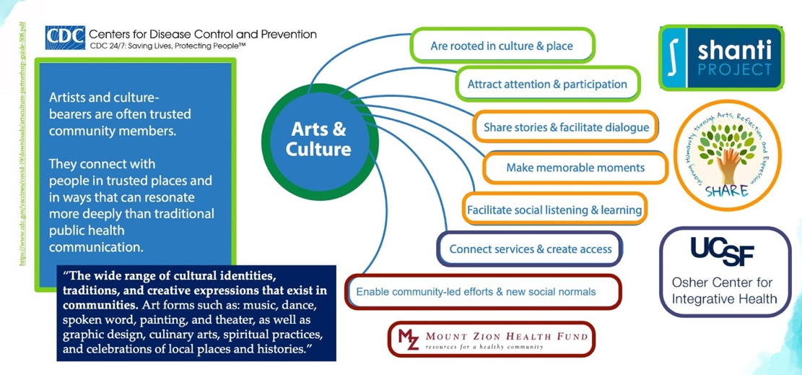
“Artists and culture-bearers are often trusted, community members. They connect with people in trusted places and in ways that can resonate more deeply than traditional public health communication.” Adapted Figure from CDC (2021). Engaging Arts and Culture for Vaccine Confidence: Quick Start Guide for Building Sustainable Partnerships. Atlanta: Centers for Disease Control and Prevention.
1c. Expanding Integrative Pain Management in the San Francisco Health Network (SFHN)

Project Team: Maria T. Chao, DrPH, MPA (project lead, OCIH), Denise Ruvalcaba (project coordinator, OCIH), Pamela Swedlow, MD (SFHN), Jesse Wennik, NP (SFHN), Folashade Wolfe-Modupe, MD (SFHN), IHEAR predoctoral fellow

Description of Community Organization & History of Partnership

San Francisco Health Network (SFHN) is the healthcare services arm of the SF Department of Public Health. It includes a network of 5 hospital-based primary care clinics and 14 community-based and public primary care clinics, caring for nearly 60,000 racially, ethnically and linguistically diverse patients (15% Black/African American, 17% White, 25% Asian, 36% Latine). Primary care safety net clinics are a critical resource for the publicly insured, uninsured, and underserved, and are uniquely positioned for providing care to vulnerable populations and reducing disparities in pain management. Clinicians and researchers at SFHN and the UCSF Osher Center for Integrative Health have a longstanding partnership focused on providing comprehensive integrative pain management to SFHN patients with chronic pain. With support from the Mt Zion Health Fund in 2016, we piloted a group Integrative Pain Management Program at the Tom Waddell Urban Health Clinic in the Tenderloin, the San Francisco neighborhood experiencing the greatest concentration of deaths related to prescription opioids.

Project goals to build capacity for IHE

Our vision is for all SFHN patients with chronic pain to have equitable access to integrative care. IPMP has been consistently offered since 2016, but expansion and greater reach has been limited by the number of clinicians who are trained to provide integrative care. Like many safety-net health clinics, SFHN primary care clinics currently have limited capacity to offer guideline-concordant care for chronic pain, including integrative health services. The goal of the current project is to build capacity by providing integrative health trainings to SFHN providers, with a focus on multilingual integrative pain care. Proposed activities were developed jointly by SFHN providers and OCIH faculty. SFHN providers shared input on type of integrative health training that would be of value to primary care providers, current barriers to accessing integrative health in SFHN, and existing programs and standing meetings that could be leveraged for training opportunities.

Timeline and Project Plans

Year 1 (months 1-6). Plan a series of integrative health trainings for SFHN providers.
- Meet with primary care leadership, residency program directors, and clinical fellowship directors to identify key needs and areas of synergy for integrative health trainings
- Identify optimal meeting times and logistics for trainings
- Develop materials on cultural appropriation, hierarchical power dynamics and multilingual care that can be incorporated into all trainings. Trainees will learn frameworks for how to consider these topics and apply them to interprofessional practice, including healing practice acknowledgements.

Years 1-2 (months 7-24). Offer trainings to SFHN primary care providers and to UCSF primary care residents based at SFGH. We anticipate offering three types of trainings to ≥50 SFHN clinicians (~25 primary care providers and ~25 primary care residents), prioritizing multilingual clinicians:
- The NADA protocol, which involves placement of five small, sterilized disposable needles or seeds into specific sites on each ear. It was developed by the National Acupuncture Detoxification Association and has been implemented in a broad range of settings to reduce stress, minimize withdrawal symptoms, and relieve symptoms associated with trauma. Our training will not use acupuncture needles, but rather will use beads or seeds that can be applied by a range of clinicians.
- Facilitating integrative group medical visits, led by the founders of the Integrated Center for Group Medical Visits, an organization dedicated to implementing, educating, innovating and evaluating group medical visits as an efficient model for integrative primary care.
- Simple and versatile integrative health approaches such as breathing exercises, mindfulness suboccipital release technique, that can be incorporated into brief primary care visits.

Year 3. Support primary care providers’ implementation of integrative health approaches in clinical practice.
- Provide ongoing training and consultations with integrative health experts
- Create a forum for resource sharing and questions about integrative primary care
- Evaluate impact of trainings including whether primary care providers have implemented integrative health and eliciting feedback on opportunities, challenges, and barriers to using knowledge and skills from trainings

