|  |  |  |  |  |  |  |  |
| --- | --- | --- | --- | --- | --- | --- | --- |
| Number of occurrences | 08/19-08/31 | 09/01-09/30 | 10/1-10/31 | 11/1-  11/30 | 12/1  12/31 | 01/01  01/30 | 02/01  02/14 |
| Reschedule | 0 | 1 | 1 | 0 | 3 | 19 | 13 |
| No Show | 7 | 10 | 16 | 11 | 12 | 21 | 5 |
| Cancellation | 0 | 1 | 5 | 5 | 8 | 15 | 8 |
| Total | 7 | 12 | 23 | 16 | 23 | 55 | 26 |
| Work days | 10 | 21 | 23 | 18 | 19 | 21 | 10 |
| Daily Average Scheduled Test | 10.5 | 10.9 | 12 | 12.72 | 11.84 | 14.57 | 16.57 |

1. Data Missed Opportunity
2. From 8/19-24 to 02/14/25

Total Number of Missed opportunities 162

Total Number of Cases Booked 1592

Percentage of Missed Opportunity 10.2%

Average Scheduled Daily Cases 12.72

Total Work Days 122

1. Projected Daily Expenses to Perform Each Exam

Professional Services:

NP $120.00

HLT $65.00

Sonographer $130

Physician $150

Room $100

Projected Cost $565.00

1. Cost of Studies 2025

|  |  |
| --- | --- |
| Billed amount for the following services: |  |
| Treadmill Only | 3,041 |
| Treadmill Stress Echo | 6,082 |
| Dobutamine Stress Echo | 9,407      with contrast  10,203 |
| Supine Bicycle Echo | 9,407      with contrast  10,203 |
| Cardiopulmonary Exercise Test (CPET) | 5,638 |
| Tilt Table Testing | 1,716 |

**Average Cost of Procedures Billed $5881**

1. **RETURN ON INVESTMENT (ROI)** – **$914,166**

|  |  |  |  |
| --- | --- | --- | --- |
| STEP | Process | Calculation | Result |
| 1 | Average cost of billed procedures X Average scheduled daily cases | $5,881 X 12.72 | $74,806.32 (Projected daily revenue) |
| 2 | Projected daily revenue X Daily percentage of missed opportunity | $74,806.32 X 10.2% | $7,630 (Lost daily revenue) |
| 3 | Lost daily revenue X Total work days | $7,630 x 122 | $930,889 (Total revenue lost biannually) |
| 4 | Total revenue lost biannually x annual | $930,889 X 2 | **$1,861,779 (Annual Lost Revenue)** |
| 5 | Projected daily revenue x projected goal of missed opportunity with this project | $74,806.32 X 5.5% | $4114.43 (Projected decrease in missed opportunity |
| 6 | Projected decrease in missed opportunity with this project x Total work days | $4,114.43 X 122 | $501,950 (biannual savings in missed opportunity) |
| 7 | Biannual savings in missed opportunity x annual | $501,950 x 2 | **$1,003,900 (Annual Savings if missed opportunity improves)** |
| 8. | Annual lost revenue – Annual savings if missed opportunity improves | $1,861,779 – $1,003,900 | **$857,879 Return Of Investment** |

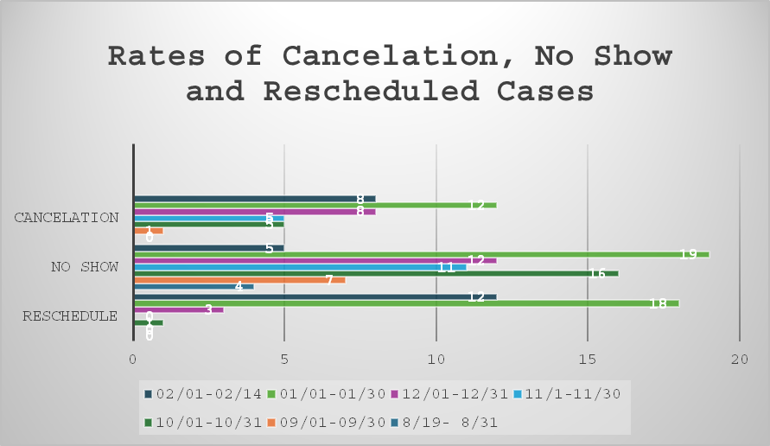

Table 2. Rates of Cancelation, No Show and Rescheduled Cases

Data:

08/19 SC TSE NS

MC CPET NS

08/21 SM CPET NS

08/26 LM TSE NS

08/26 NG CPET NS

08/27 SD TSE NS

08/30 OS TSE NS

_________

09/03 LD TSE NS

09/05 LS CPET NS

09/09 CC TSE NS

09/12/ EE TSE Cancelled Due to abnormal echo

09/18 LM Tilt Refused/cancelled

09/23 PM BSE No show

BA TSE No show

09/25 BD CPET No show

MJ Tilt NS

SL TSE NS

09/30 LC CPET NS

CPS TME NS

10/1 PM TILT Cancel (no staffing)

ME BSE Cancel (no staffing)

10/2 PF TSE Canceled d/t recent fall and fracture

10/3 DR BSE NS

10/9 KR TSE NS

10/11 DP BSE No show

JM TSE NS

BM TMO NS

10/14 GB CPET NS

ZS TSE NS

10/15 RP DSE No show

10/16 BK DSE No show

10/17 SB TSE Cancelled due to new AS

10/18 DJ DSE NS

10/21 AF DSE NS

10/22 DJ DSE NS

HM CPET NS

10/24 RJ DSE NS

OE CPET NS

10/25 RJ TSE NS Pt already had Catheterization

10/30 EU TSE Canceled Mobility limitations

10/31 LC Tilt RS IV misinformation/ hard stick/ refused

11/1 LY DSE NS

HR TSE Canceled Knee Pain

11/7 WB CPET NS

11/13 LA TE canceled

11/18 RM CPET NS

11/19 LY CPET NS

11/20 LW CPET NS

FJ TSE NS

MK TSE NS

11/21/25 ME TTT NS

11/22/25 BM TSE NS

11/25/25 GE TSE canceled –active leg disease

11/26/25 BS DSE NS

11/26/25 BS TSE NS

CJ TSE Canceled Uncontrolled HTN

11/27 JR TSE Canceled Mobility Issues

12/3/25 GC TSE NS

12/4/25 KM TILIT NS

BD CPET NS

ER TSE NS

12/6/25 KK TSE NS

12/10/25 OS TSE Canceled Uncontrolled HTN

12/11/25 AM DSE RS

FC TSE NS

HN CPET NS

12/13/25 CRD BSE canceled

AW TSE Canceled Denied d/t insurance

12/16/25 FG TSE NS hemiplegia

12/17/25 TK CPET Canceled

NJ DSE Canceled

12/18/25 PM Tilt NS

CR CPET NS

CE CPET RS

AM DSE RS

EC TSE Canceled Sick

12/19/25 SN TSE NS

12/20/25 RK TMO Canceled

12/23/25 PT TSE Canceled

12/30/25 LA TMO NS

01/2/25 NJR TSE NS

SF BSE Canceled due to pain

01/03/25 BG TSE NS

EGY TSE Reschedule

01/06/25 ZTJ DSE Canceled (DSE- converted to TSE)

BD CPET Canceled

Pt cpet Canceled

KN TT Rescheduled

01/07/25 EGE TSE NS

TM TM Canceled

VF TSE Canceled Uncontrolled HTN

01/08/25 DA TSE NS

DF TSE Not Seen

CM TSE Rescheduled

01/10/25 GF TMO NS

SBC TSE NS

EGY TSE Canceled Due to Hypertension

01/13/25 JT TMO RS

TJ TSE Canceled Neck fracture

HS TSE Canceled

PTM CPET rescheduled

01/14/25 CE CPET NS

01/15/25 RN TE NS

GH TMO RS Abnormal EKG

01/16/25 FG BSE NS

01/17/25 VE TMO NS

KOA DSE Rescheduled

RD DSE Rescheduled

01/21/2025 HD TTT RS

HD TSE Canceled

VA DSE RS

LYM DSE NS

KM TSE Reschedule- Hypertension

GO CPET RS

KD TSE RS

HSJ TSE RS

NL TSE NS

01/22/25 ONA TT NS

GP TSE NS

01/23/25 CE TSE NS

RFS BSE NS Pt wants to walk instead of BSE

Bg tse ns

01/24/25 gl tse RS

AK TSE NS

01/27/25 SS TSE NS

01/28/25 KM TSE Cancelled

FG DSE RS

WJ DSE NS

VA TSE RS

01/29/25 EK TTT RS

AJ CPET Cancelled Needs regular TSE vs CPET

01/31/25 SJ TMO Cancelled

MA TSE Cancelled

VM TMO RS

CH TSE Cancelled high gradients with current symptoms

02/03/25 VA CPET NS

IKM TSE NS

WBD CPET Cancelled

02/04/25 FS BSE Cancelled Knee Pain

HLW TSE Cancelled

KY TSE Cancelled

JE DSE RS

SA TSE RS

02/05/25 JE DSE RS

TH TSE NS

RK TSE RS

SH CPET RS

CM TSE NS

02/06/25 EA TTT RS

KE TTT RS

02/07/25 TV TSE/HCM NS due to knee pain and brace

WS TSE RS abnormal EKG baseline

02/10/25 WY TSE RS

MC TE Cancelled

BP Dobutamine Cancelled Took Metoprolol

02/12/25 BC TSE RS

WG CPET RS

SA TSE RS

BC TSE RS

MP TSE Cancelled Hip Pain

02/13 DD CPET